Programme Code: DT9231
Module Code: DATA MATH 9102
CRN 32040

TECHNOLOGICAL UNIVERSITY DUBLIN
KEVIN STREET CAMPUS

_____________

Postgraduate Certificate in Data Science

Year 1
______________
SUPPLEMENTAL EXAMINATIONS 2019/20
______________

Probability and Statistical Inference

Dr. Bojan Božić
Dr. Deirdre Lillis
Dr. Ignacio Castiñeiras

Two Hours

SOLUTIONS

1. | (a) | What kind of hypothesis is ‘Children can learn a second language faster before the age of 7’.  (2 marks)  A one-tailed hypothesis.
 | (b) | A variable manipulated by a researcher is known as?  (2 marks)  Independent variable.
 | (c) | What kind of variable is IQ, measured by a standard IQ test?  (2 marks)  A continuous variable.
 | (d) | A frequency distribution in which high scores are most frequent (i.e. bars on the graph are highest on the right‐hand side) is said to be?  (3 marks)  Negatively skewed.
 | (e) | Variation due to variables that have not been measured is known as?  (3 marks)  Unsystematic variance.
 | (f) | What does a 95% confidence interval for the mean of a given sample say?  (3 marks)  95 out of 100 confidence intervals will contain the population mean.
 | (g) | What is a type II error?  (3 marks)  We conclude that there is not an effect in the population when in fact there is.
 | (h) | If we calculated an effect size and found it was r = .21, which expression would best describe the size of the effect?  (3 marks)  Small to medium.
 | (i) | What is the mode, estimate of standard deviation in the population and range of this data?  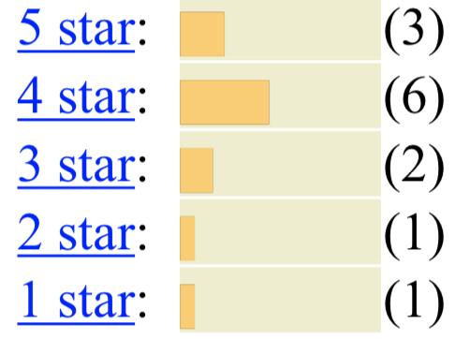  (6 marks)  4, 1.18, 4.
 | (j) | What can we say about this data?  (continues on next page)  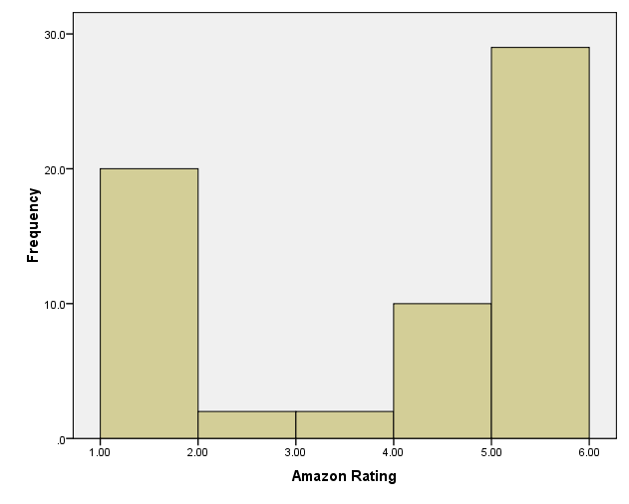  (3 marks)  The data is approximately bimodal.
 | (k) | Different interventions have been tried to stop hiccups. Looking at the graph below, which intervention is the best cure?  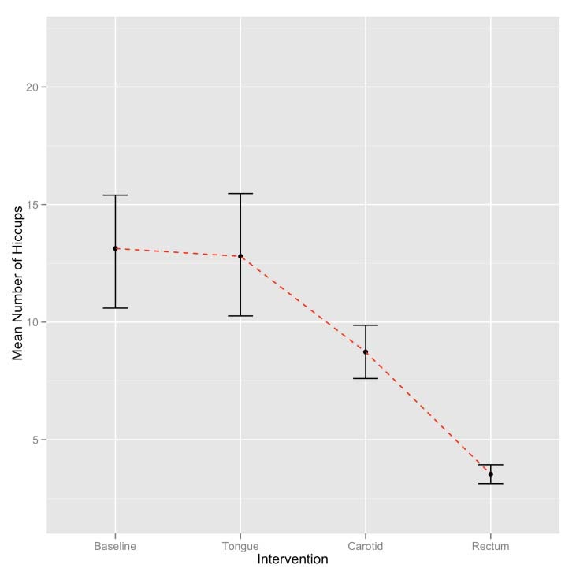  (3 marks)  Rectum.
 | (l) | The assumption of homogeneity of variance is met when ?  (3 marks)  Variances in different groups are approximately equal.
 | (m) | What is covariance?  (5 marks)  - An unstandardized version of the correlation coefficient.  - A measure of the strength of relationship between two variables.  - Dependent on the units of measurement of the variables.
 | (n) | What is Pearson’s correlation coefficient and what can it be used for?  - marks)  - It can be used as an effect size measure.  - It varies between –1 and +1.  - It can be used on ranked data.
 | (o) | How much variance has been explained by a correlation of .9?  (3 marks)  81%

2. | (a) | What does t-statistic do and what can it be used for?  (5 marks)  - The t‐statistic tests whether the regression coefficient, b, is equal to 0.  - The t‐statistic provides some idea of how well a predictor predicts the outcome variable.  - The t‐statistic can be used to see whether a predictor variables makes a statistically significant contribution to the regression model.
 | (b) | What is the following graph showing? Explain your answer and provide your interpretation.  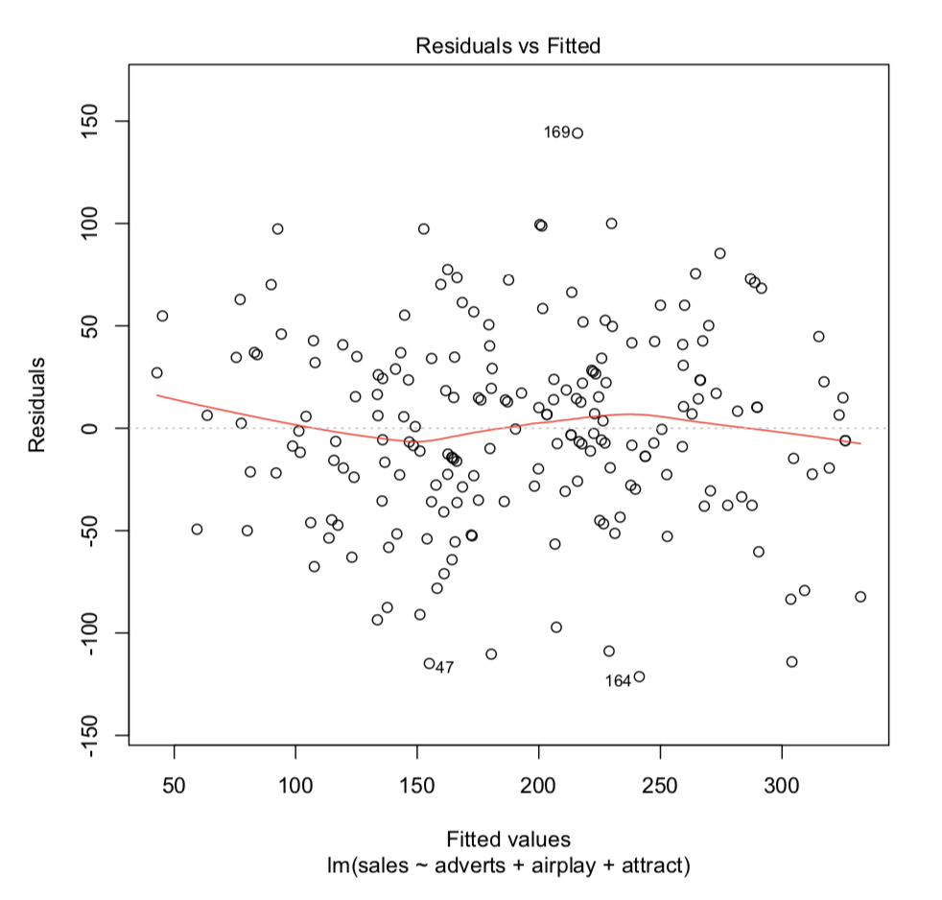  (5 marks)  Regression assumptions that have been met.
 | (c) | Recent research has shown that lecturers are among the most stressed workers. A researcher wanted to know exactly what it was about being a lecturer that created this stress and subsequent burnout. She recruited 75 lecturers and administered several questionnaires that measured: Burnout (high score = burnt out), Perceived Control (high score = low perceived control), Coping Ability (high score = low ability to cope with stress), Stress from Teaching (high score = teaching creates a lot of stress for the person), Stress from Research (high score = research creates a lot of stress for the person), and Stress from Providing Pastoral Care (high score = providing pastoral care creates a lot of stress for the person). The outcome of interest was burnout, and Cooper’s (1988) model of stress indicates that perceived control and coping style are important predictors of this variable. The remaining predictors were measured to see the unique contribution of different aspects of a lecturer’s work to their burnout. The R output is below and the remaining questions relate to this output.  summary(burnoutModel.1)  Call:  glm(formula = burnout ~ loc + cope, family = binomial(), data = burnoutData)  Deviance Residuals:  Min 1Q Median 3Q Max  -2.9217 -0.5163 -0.3730 0.1273 2.0848  (continues on next page)  Coefficients:  Estimate Std. Error z value Pr(>|z|)  (Intercept) -4.484493 0.379458 -11.818 < 2e-16 ***  loc 0.061080 0.010915 5.596 2.19e-08 ***  cope 0.082714 0.009369 8.829 < 2e-16 ***  ---  Signif. codes: 0 ‘***’ 0.001 ‘**’ 0.01 ‘*’ 0.05 ‘.’ 0.1 ‘ ’ 1  (Dispersion parameter for binomial family taken to be 1)  Null deviance: 530.11 on 466 degrees of freedom  Residual deviance: 364.18 on 464 degrees of freedom  AIC: 370.18  Number of Fisher Scoring iterations: 5  logisticPseudoR2s(burnoutModel.1)  Pseudo R^2 for logistic regression  Hosmer and Lemeshow R^2  Cox and Snell R^2  Nagelkerke R^2  0.313  0.299  0.441  exp(burnoutModel.1$coefficients)  (Intercept) loc cope  0.01128261 1.06298389 1.08623164  exp(confint(burnoutModel.1))  2.5 % 97.5 %  (Intercept) 0.005160721 0.02292526  loc 1.041229885 1.08691181  cope 1.067210914 1.10722003  summary(burnoutModel.2)  Call:  glm(formula = burnout ~ loc + cope + teaching + research + pastoral,  family = binomial(), data = burnoutData)  Deviance Residuals:  Min 1Q Median 3Q Max  -2.41592 -0.48290 -0.28690 0.02966 2.63636  Coefficients:  Estimate Std. Error z value Pr(>|z|)  (Intercept) -4.43993 1.08565 -4.090 4.32e-05 ***  loc 0.11079 0.01494 7.414 1.23e-13 ***  cope 0.14234 0.01639 8.684 < 2e-16 ***  teaching -0.11216  research 0.01931  pastoral 0.04517  ---  0.01977 -5.673 1.40e-08 ***  0.01036 1.863 0.062421 .  0.01310 3.449 0.000563 ***  Signif. codes: 0 ‘***’ 0.001 ‘**’ 0.01 ‘*’ 0.05 ‘.’ 0.1 ‘ ’ 1  (Dispersion parameter for binomial family taken to be 1)  Null deviance: 530.11 on 466 degrees of freedom  Residual deviance: 321.20 on 461 degrees of freedom  AIC: 333.2  Number of Fisher Scoring iterations: 6  modelChi; chidf; chisq.prob  [1] 208.9086  [1] 5  [1] 0  logisticPseudoR2s(burnoutModel.2)  Pseudo R^2 for logistic regression  Hosmer and Lemeshow R^2 0.394  Cox and Snell R^2 0.361  exp(burnoutModel.2$coefficients)  (Intercept) loc cope teaching research pastoral  0.01179680 1.11715594 1.15296414 0.89389904 1.01949919 1.04620942  exp(confint(burnoutModel.2))  2.5 % 97.5 %  (Intercept) 0.001317788 0.09419003  loc 1.086274965 1.15212014  cope 1.118430575 1.19286786  teaching 0.858532732 0.92793154  research 0.999115252 1.04068582  pastoral 1.020119629 1.07403586  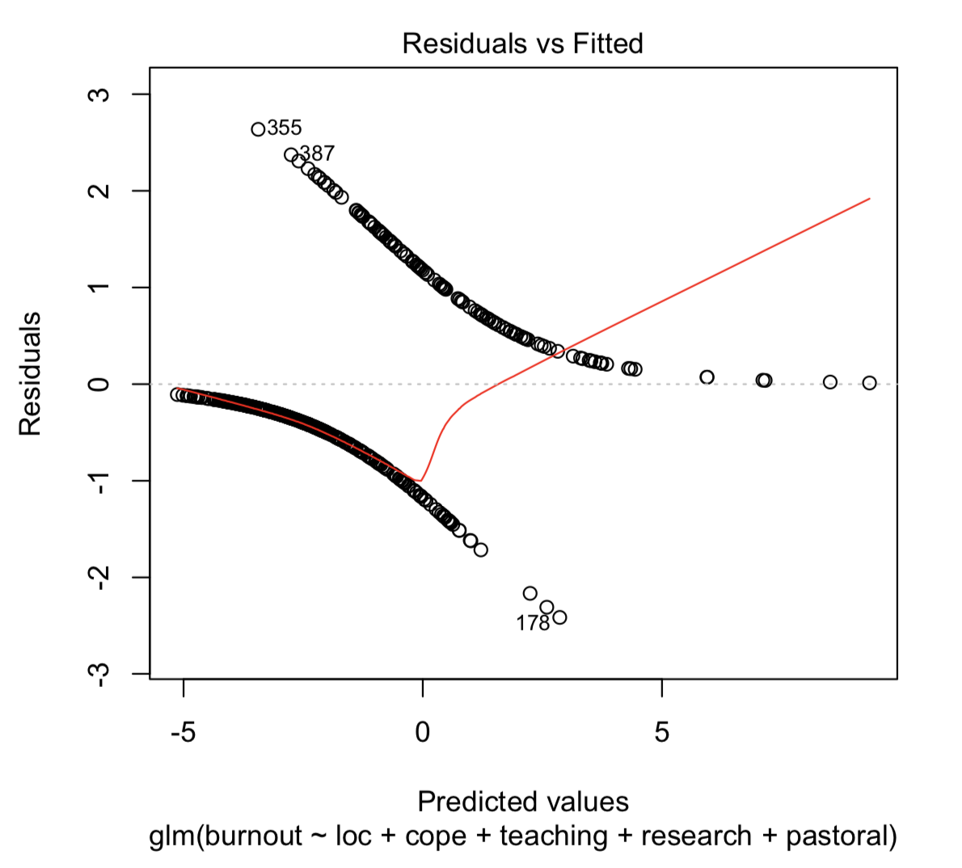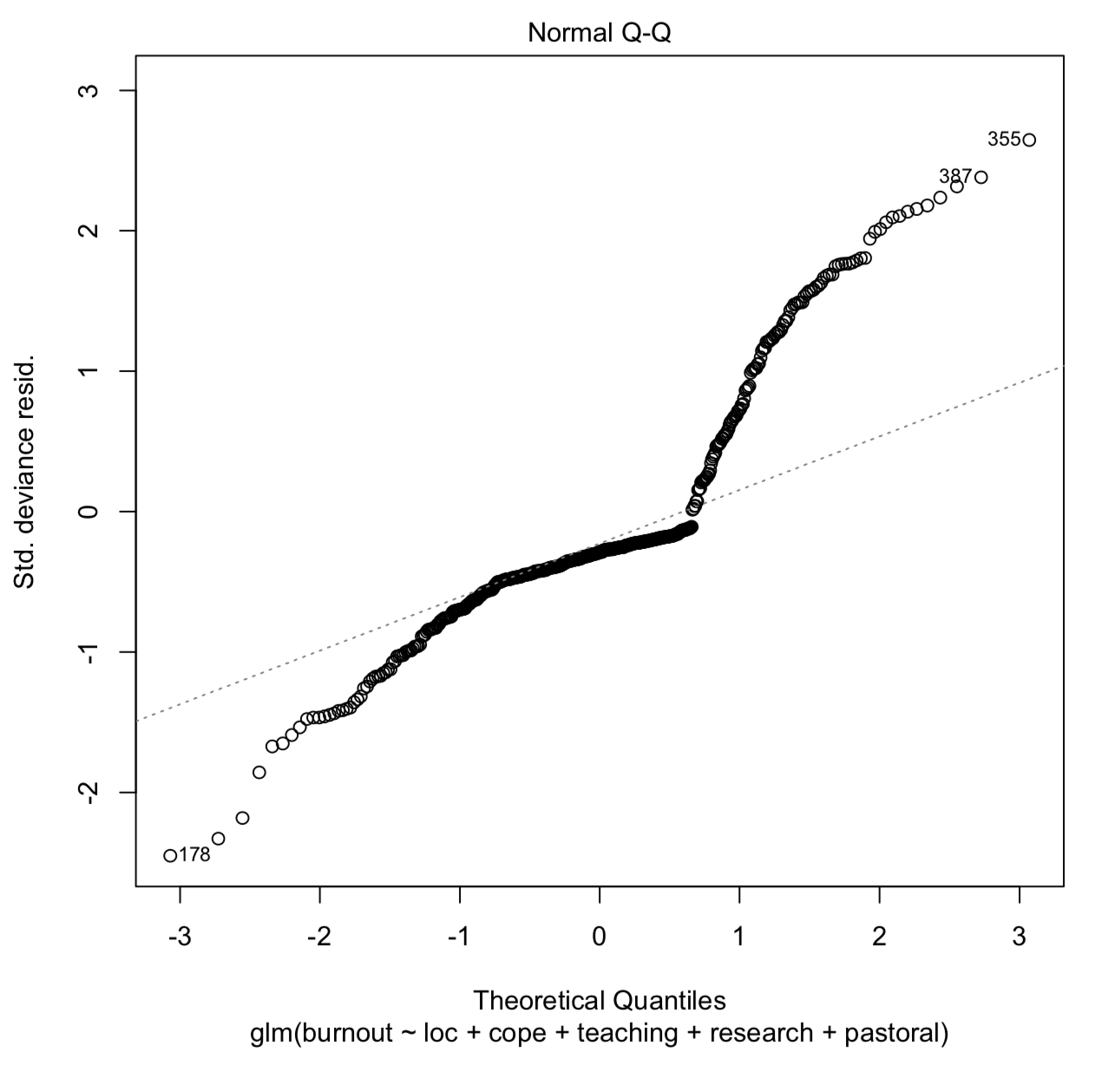  - What analysis has been carried out?  - How much variance in burnout does the model explain?  - What does the normal Q-Q plot show?  - Interpret the model in your own words.  (30 marks)  - Hierarchical multiple regression.  - 36.1–53.1%  - That the data are not normally distributed.
 | (d) | What is the Wald statistic?  - marks)  - The Wald statistic assesses the individual contribution of a predictor to a logistic regression model.  - The Wald statistic tends to be biased when the regression coefficient is large.  - The Wald statistic is analogous to the t‐statistic in regression.
 | (e) | What are the odds of an event?  (4 marks)  The ratio of the probability of an event happening to the probability of the event not happening.

3. | (a) | What does the error bar on an error bar chart represent?  (5 marks)  - The confidence interval round the mean.  - The standard error of the mean.  - The standard deviation of the mean.
 | (b) | What is an indendent t-test used for?  (5 marks)  Differences between means of groups containing different people when the data are normally distributed, have equal variances and data are at least interval.
 | (c) | When can the t-test be characterised as a regression model?  (5 marks)  The experimental groups are represented by a binary variable (i.e. coded 0 and 1).
 | (d) | A researcher measured people’s physiological reactions while watching horror films and compared them to when watching erotic films and a documentary about wildlife. Different people viewed each type of film. The resulting data were normally distributed and the variances across groups were similar. What test should be used to analyse the data and why?  (5 marks)  Independent analysis of variance.
 | (e) | What is Bonferroni Correction and why is it needed?  (5 marks)  You apply a criterion for significance based on the usual criterion for significance (.05) divided by the number of tests performed.
 | (f) | A music teacher had noticed that some students went to pieces during exams. He wanted to test whether this performance anxiety was different for people playing different instruments. He took groups of guitarists, drummers and pianists (variable = Instru) and measured their anxiety (variable = Anxiety) during the exam. He also noted the grade of exam they were taking (in the UK, musical instrument exams are known as ‘grades’ and range from 1 to 8). He wanted to see whether the type of instrument played affected performance anxiety when controlling for the grade of the exam. What analysis should he use and why?  (5 marks)  Analysis of covariance.
 | (g) | The next part of the R output for the example in the previous question is given below. What effect did the type of instrument played have?  Response: ANXIETY  Sum Sq Df F value Pr(>F)  (Intercept) 32903.788 1 197.594 .000 ***  GRADE 907.833 1 5.452 .023 *  INSTRU 6351.708 2 19.072 .000 ***  Residuals 9325.228 56  (5 marks)  The type of instrument played in the exam had a significant effect on the level of anxiety experienced even after the effect of the grade of the exam had been accounted for.
 | (h) | What does the table of means from the previous question tell us?  (continues on next page)  INSTRU Mean (SE)  Simultaneous Confidence Intervals  Multiple Comparisons of Means: Tukey Contrasts  95% family-wise confidence level  Linear Hypotheses:  Drums – Guitar == 0  Drums – Piano == 0  Piano – Guitar == 0  Estimate lwr upr  1.7857 15.355 35.830  2.2249 2.527 22.219  0.4392 2.804 23.634  (5 marks)  Guitarists were significantly less anxious than pianists and drummers, and drummers were significantly more anxious than pianists.
  Guitar 72.633 (3.066)
  Piano 85.852 (2.887)
  Drums 98.225 (2.761)
 | (i) | Field & Lawson (2003) reported the effects of giving 7–9‐year‐old children positive, negative or no information about novel animals (Australian marsupials). This variable was called ‘Infotype’. The gender of the child was also recorded. The outcome was the time taken for the children to put their hand in a box in which they believed either the positive, negative, or no information animal was housed (positive values = longer than average approach times, negative values = shorter than average approach times). The output of their analysis is below. What analysis has been done?  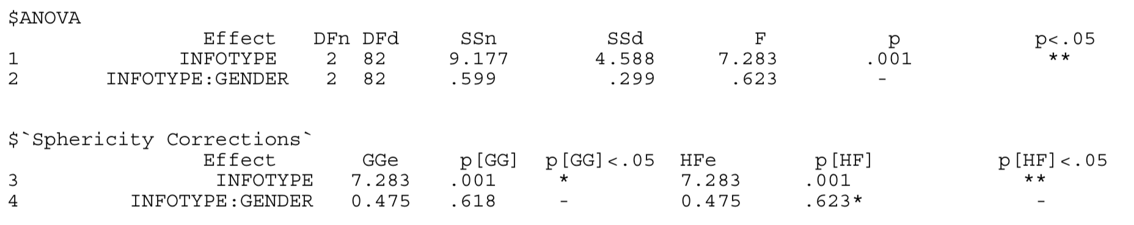  (5 marks)  A two‐way mixed ANOVA.
 | (j) | An experiment was conducted to see how people with eating disorders differ in their need to exert control in different domains. Participants were classified as not having an eating disorder (control), as having anorexia nervosa (anorexic), or as having bulimia nervosa (bulimia). Each participant underwent an experiment that indicated how much they felt the need to exert control in three domains: eating, friendships and the physical world (this final category was a control domain in which the need to have control over things like gravity or the weather was assessed). So all participants gave three responses in the form of a mean reaction time; a low reaction time meant that the person did feel the need to exert control in that domain. The variables have been labelled as group (control, anorexic, or bulimic) and domain (food, friends or physics). The R output from an analysis is shown below.  - What analysis has been conducted?  - What can we conclude about the main effect of the group variable?  (continues on next page) 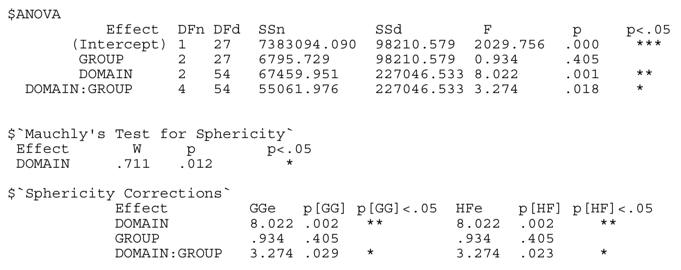  (5 marks)  Two‐way mixed ANOVA.  When ignoring the type of domain, people who differ with regard to eating disorders did not significantly differ in their need to exert control, F(2, 27) = 0.93, p > .05.

